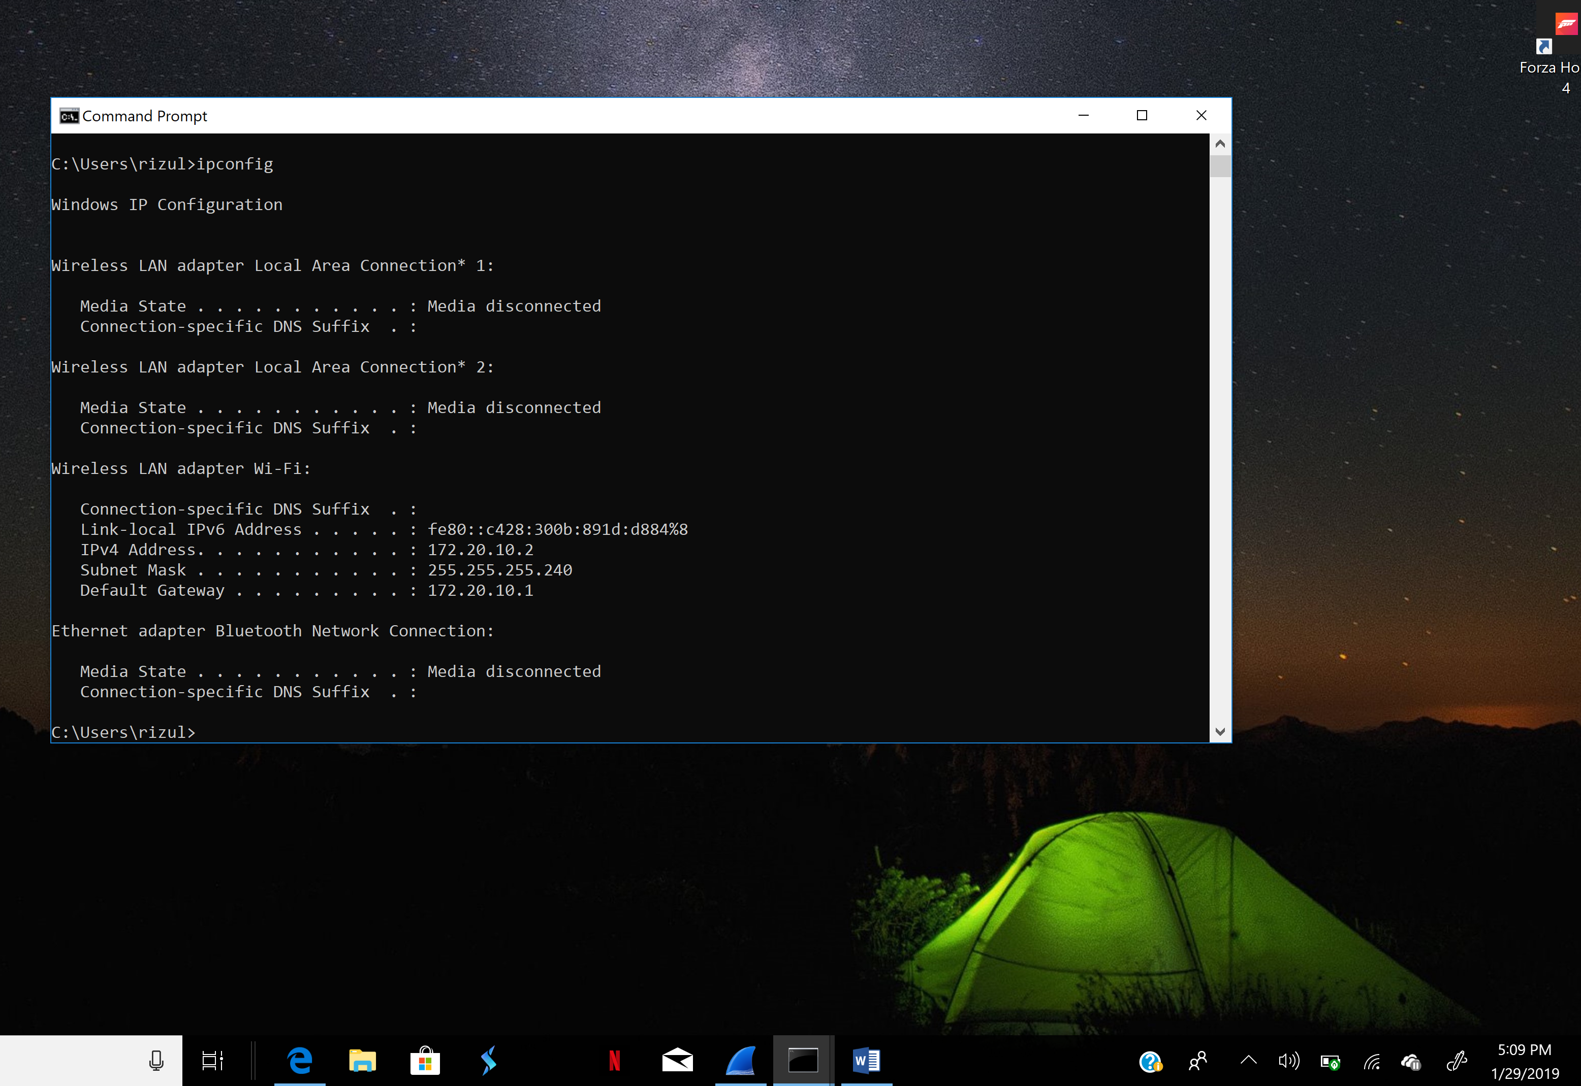

1. What is the Internet address of your computer?

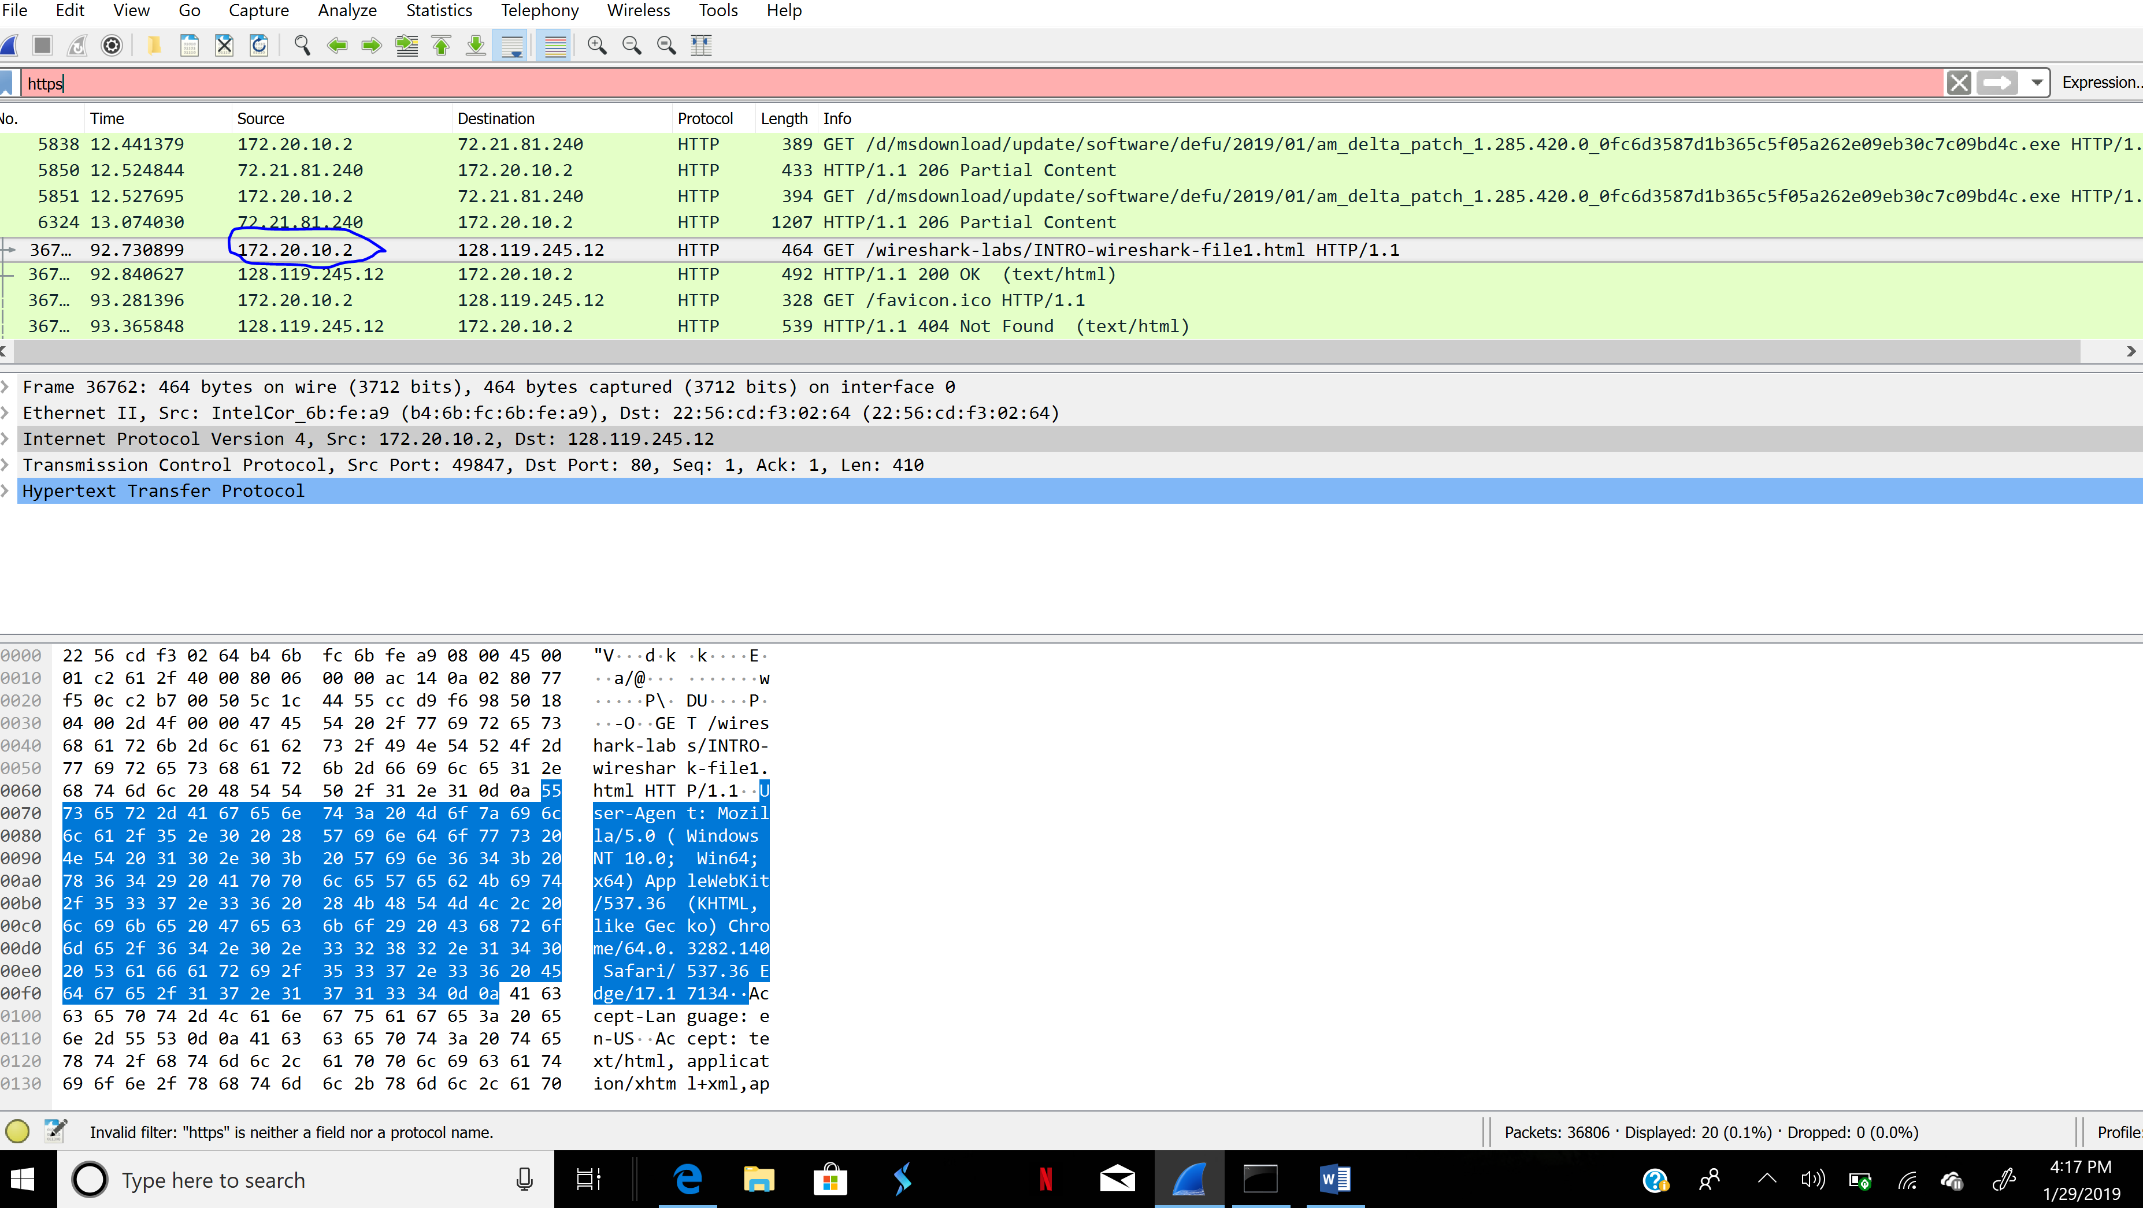

The Internet address of my computer is 172.20.10.2.

1. List 3 different protocols that appear in the protocol column in the unfiltered packet listing window in step 7 above.

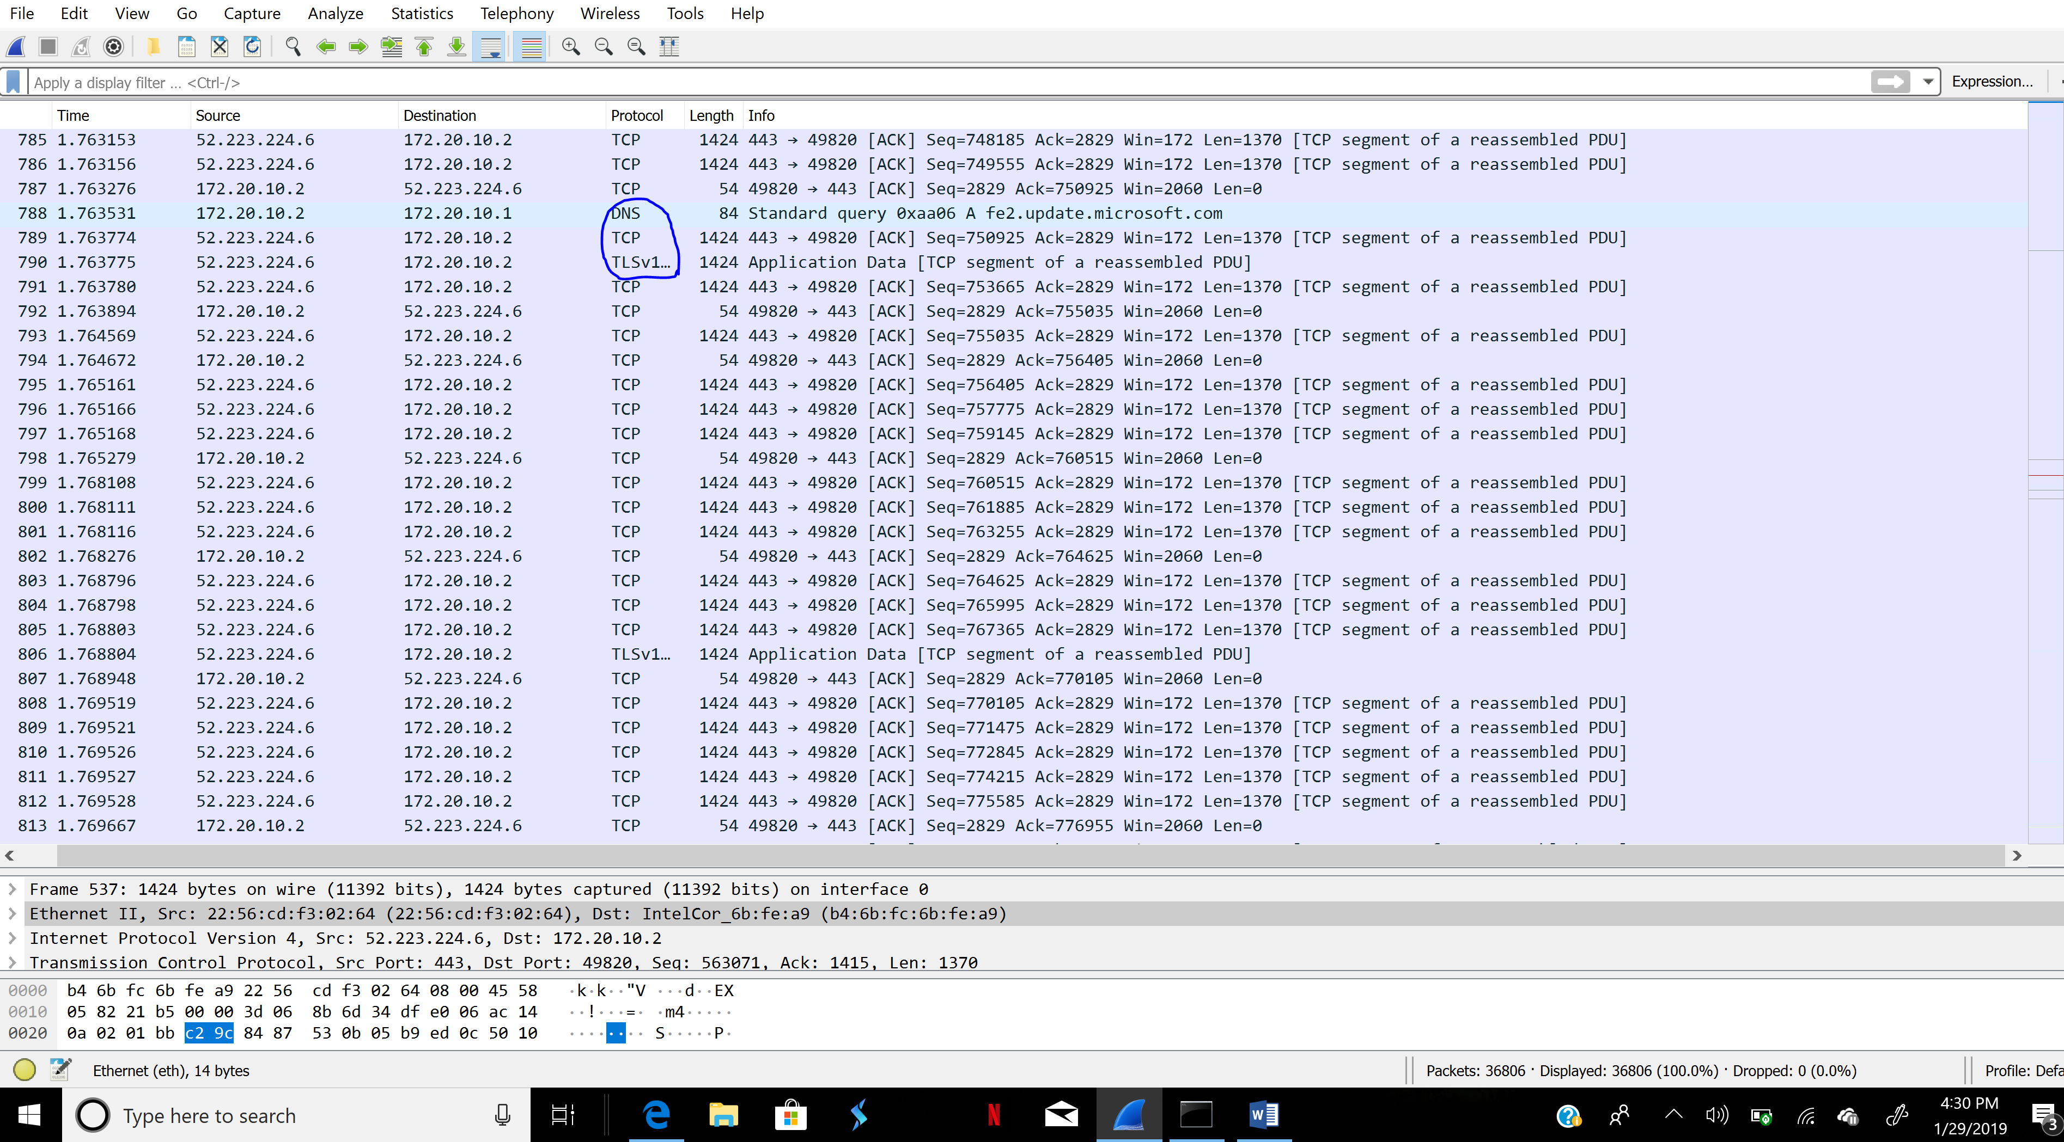

Three different protocols that appear in the protocol column are DNS, TCP and TLSv1.

1. How long did it take from when the HTTP GET message was sent until the HTTP OK reply was received? (By default, the value of the Time column in the packetlisting window is the amount of time, in seconds, since Wireshark tracing began. To display the Time field in time-of-day format, select the Wireshark View pull down menu, then select Time Display Format, then select Time-of-day.)

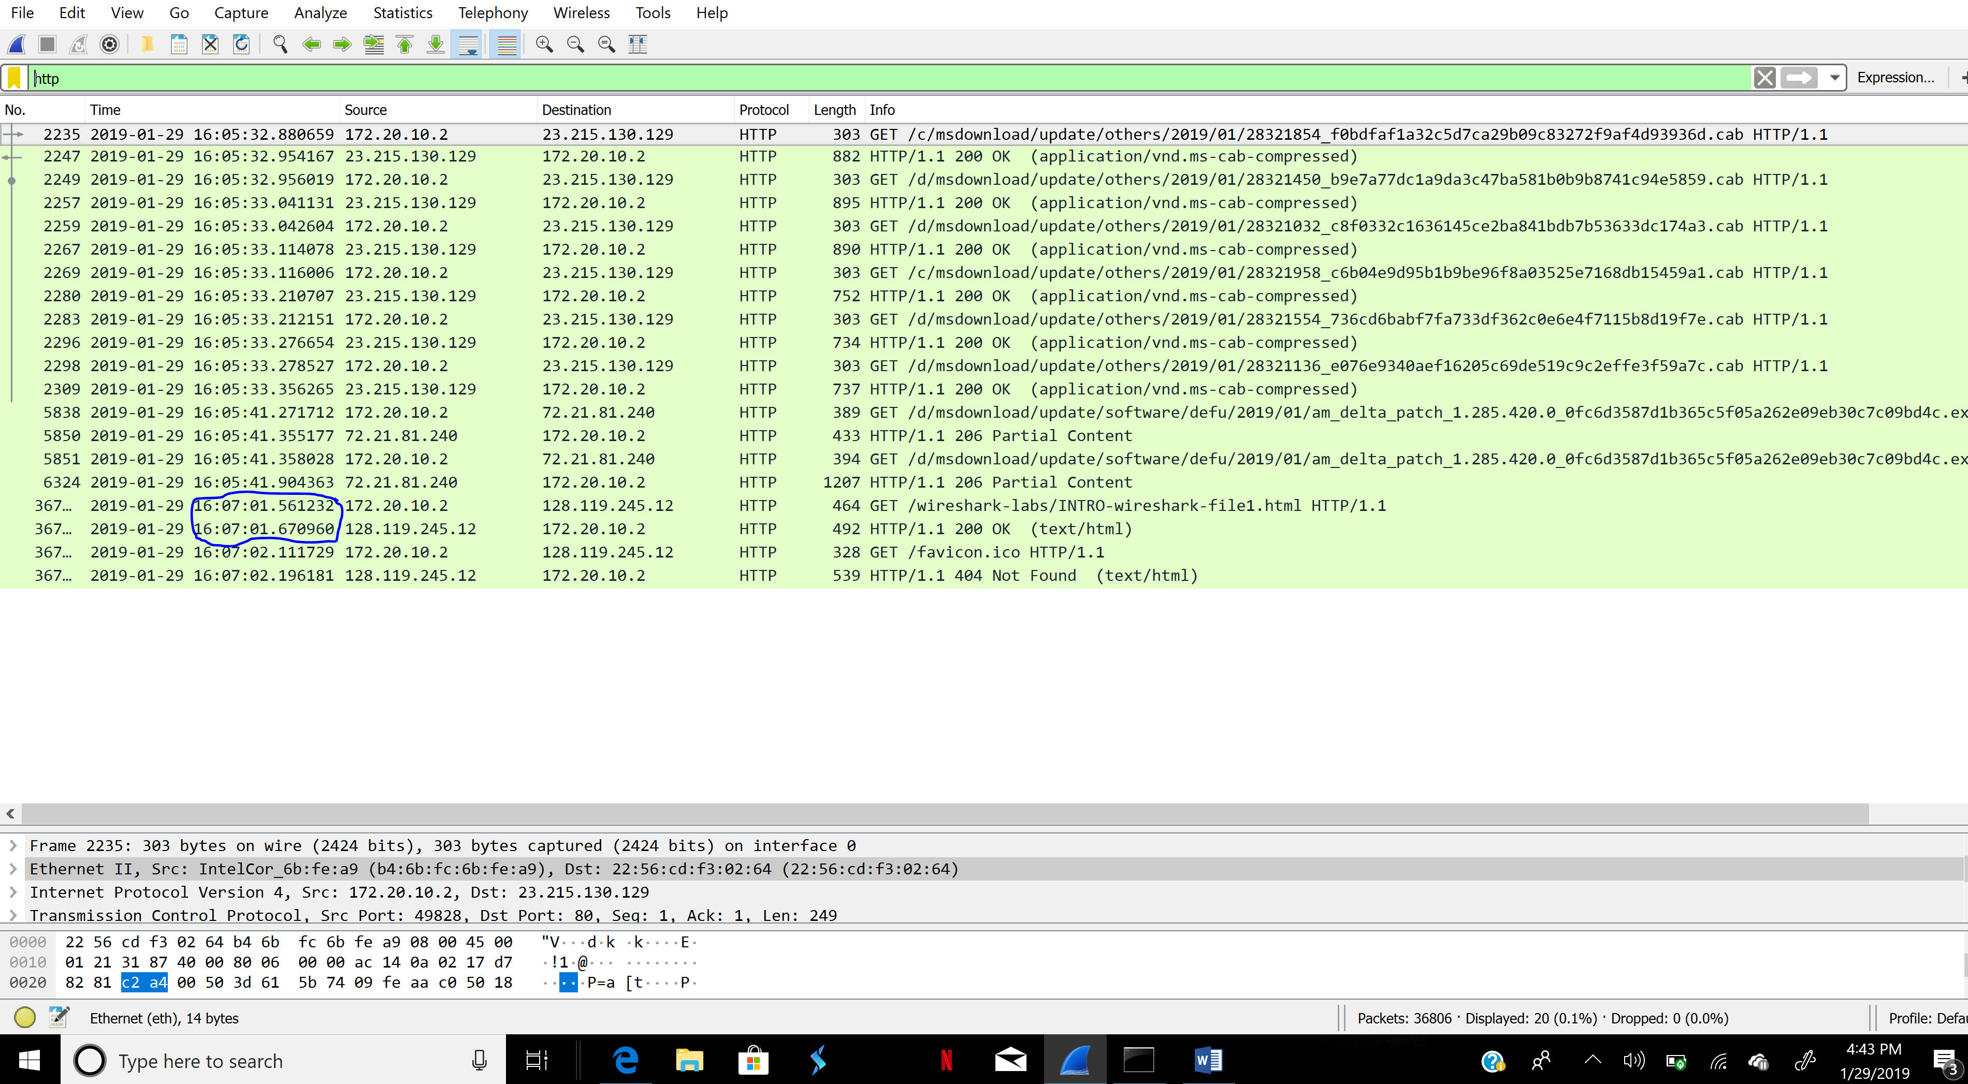

The duration of time it took from when the HTTP GET message was sent until the HTTP OK reply was received is shown below:

GET: 16:07:01.561232

OK: 16:07:01.670960

Duration= 16:07:01.670960-16:07:01.561232 = 0.109728 seconds

1. What is the Internet address of the gaia.cs.umass.edu (also known as wwwnet.cs.umass.edu)?

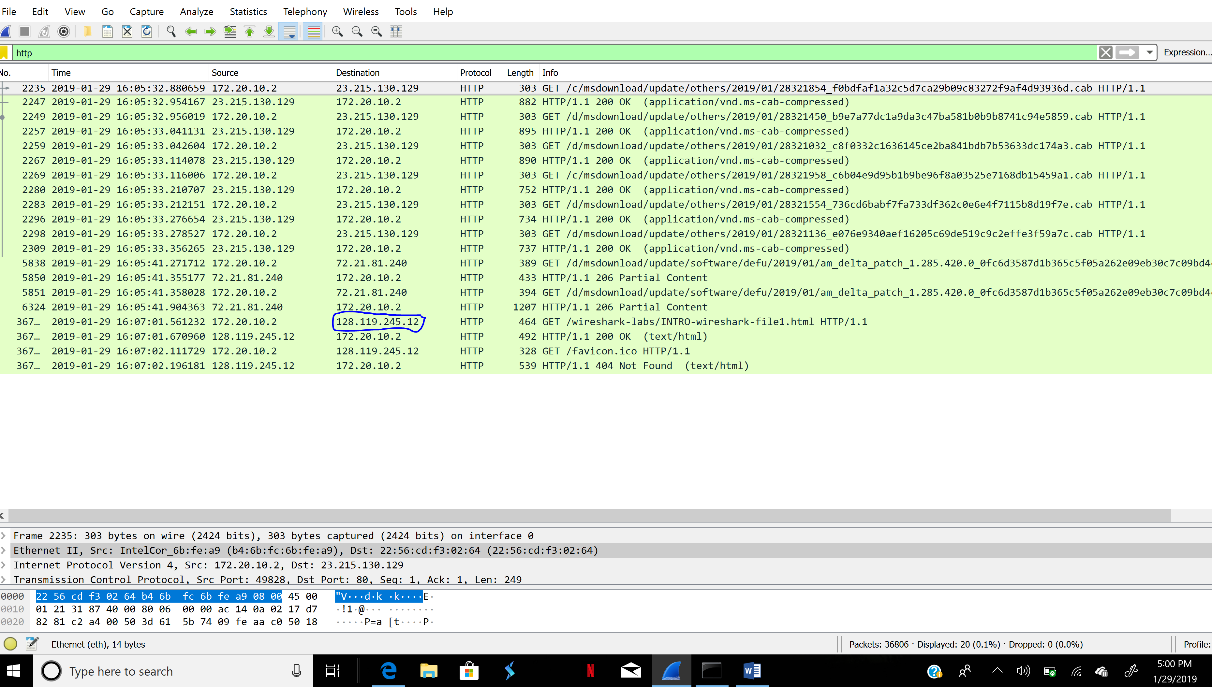

The Internet address of the gaia.cs.umass.edu is 128.119.245.12.

